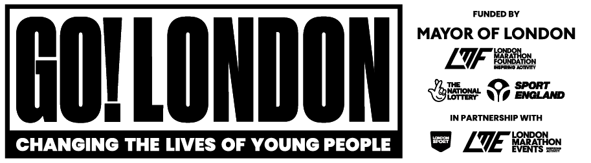

Go! London Match. Trade. Grow



Comms pack for partners

Overview
The School for Social Entrepreneurs have opened applications to the Go! London Match. Trade. Grow programme.

Funded by the Go! London Partnership and delivered by the School for Social Entrepreneurs, Match. Trade. Grow will support not-for-profit organisations and social enterprises aiming to engage young people through physical activity and sport, particularly those from underserved communities.

Go! London Match. Trade. Grow is a combination of 12 months of learning support worth over £11,000, and a Match Trading™ grant of up to £25,000.

The deadline to apply for the programme is 1pm Tuesday 14th January 2025.

What is Match Trading and how does it work?
Match Trading, first introduced by the School of Social Entrepreneurs, is an entrepreneurial approach that matches the income generated through trading activities pound-for-pound up to a specified limit.
This alternative to grant making incentivises organisations to diversify their revenue streams — whether through facility rentals, merchandise sales, or other ventures. Match Trading helps build long-term financial sustainability.

Organisations on Go! London’s Match. Trade. Grow will be expected to invest in activities that support trading growth - from staff development to marketing and product piloting - but with the clear goal of increasing access to sports for young people, particularly those from underserved communities. Match trading may be received against income generated through direct sports-related activities, such as contracts with schools or local authorities, or through unrelated ventures like catering or merchandise, with profits used to support youth sports initiatives.

Example A: You are a community boxing club looking to develop, produce, and sell T-shirts, so that you can use the profits to hire more boxing coaches and deliver more boxing classes to young people. You apply and are awarded a Match Trading grant of £25,000. You will receive 20% of the grant (£5,000) upfront, to produce and order the T-shirts. For each T-shirt you sell, the Match Trade Grow grant will match the increase in trading income pound-for-pound, up to the remaining value of the grant - £20,000.

Example B: You are a small community dance group looking to put on a ticketed show as a way to raise income to increase teacher capacity. You apply and receive a Match Trading grant of £15,000. You receive 20% of the grant (£3,000) upfront, which you use to hire a theatre space and promote the event. For each ticket you sell, the Match Trade Grow grant will match the increase in trading income pound-for-pound, up to the remaining value of the grant - £12,000.

You can find more information about match trading here: https://www.the-sse.org/stories/sse-launches-match-trading/

Who are we?

About Go! London - The biggest community sport fund in the capital, supported by The Mayor of London, London Marathon Foundation and Sport England in collaboration with London Marathon Events and London Sport. This is a new £19.5 million partnership which aims to build a fairer London, support sport and physical activity in London, and help children and young people access sport and physical activity.

For more information, visit: About Go! London | Go! London (golondon.org.uk)

About SSE - SSE was founded in 1997 by Sir Michael Young. We work with around 1000 social enterprises a year, helping leaders to start, scale and strengthen organisations that make a positive difference. But we’re not a traditional school. Learning with SSE is inspiring, action-based and accessible – no textbooks.

For more information, visit: https://www.the-sse.org/about-school-for-social-entrepreneurs/

How you can help
We’re looking for organisations in London who can help us spread the word about the Go! London Match. Trade. Grow Programme. We want to reach as many eligible organisations as possible. If you have an audience that might benefit from the programme please do share the following messages in whatever way works for you.

If you would like further information, have a group of young people that would be interested in finding out more please contact Rhys Pritchard, communication partnerships manager at SSE: rhys.pritchard@sse.org.uk

Key details:

- Go! London Match. Trade. Grow will support London-based not-for-profit organisations and social enterprises aiming to engage young people through physical activity and sport, particularly those from underserved communities
- The programme will offer a combination of 12 months of learning support worth over £11,000, plus a Match Trading™ grant of up to £25,000.
- Match. Trade. Grow is designed to help organisations build financial resilience through trading activities while investing in youth sports. This might mean generating income through direct sports-related activities, such as contracts with schools or local authorities, or through ventures like catering or merchandise, with profits used to support youth sports initiatives.

Sample posts



X / Bluesky

📣 Introducing Go! London Match Trade Grow – take your impact to the next level! 🌟 Scale up, grow your org, and invest in the future of youth sports in London, especially in underserved communities. Ready to elevate your sports initiative? ➡️ https://www.the-sse.org/go-london-match-trade-grow/ #GoLondonf

Transform young lives through sport with Go! London Match Trade Grow! 💪 If you're ready to expand trading activities to support young Londoners' access to sport, apply now! 🚀 Boost your sport-based enterprise ➡️ https://www.the-sse.org/go-london-match-trade-grow/ #GoLondon

Facebook / Instagram
📣 Introducing Go! London Match Trade Grow – level up your game plan for greater social impact. Scale your impact, grow your organisation, and invest in the future of youth sports across London, especially in underserved communities. Take your sports Initiative to the next level ➡ https://www.the-sse.org/go-london-match-trade-grow/ #golondon

Transform young lives through sport in our capital with Go! London Match Trade Grow - YOUR next opportunity 🤝If you have clear plans to expand your trading activity to support access to sport and physical activity for young people in London, apply now 👀 Boost your sport-based enterprise ➡ https://www.the-sse.org/go-london-match-trade-grow/ #golondon

Email / Linkedin copy
The School for Social Entrepreneurs have opened applications to the Go! London Match. Trade. Grow programme.

Funded by the Go! London Partnership and delivered by the School for Social Entrepreneurs, Match. Trade. Grow will support not-for-profit organisations and social enterprises aiming to engage young people through physical activity and sport, particularly those from underserved communities. Match. Trade. Grow is designed to help organisations build financial resilience through trading activities while investing in youth sports. This might mean generating income through direct sports-related activities, such as contracts with schools or local authorities, or through unrelated ventures like catering or merchandise, with profits used to support youth sports initiatives

On offer is a Match Trading grant of up to £25,000 combined with learning support worth over £11,000. This includes eight days of learning and study visits tailored to the group’s specific needs. Expert witness sessions and peer group ‘action learning’ will help participants gain the skills, knowledge, and confidence to expand their trading activity and develop their leadership capacity.

Further details can be found at https://www.the-sse.org/go-london-match-trade-grow/ - the deadline to apply is 1pm Tuesday 14th January 2025.

Partner handles
As well as ensuring that the hashtag #golondon is used in every post relating to the programme, partners should be tagged where possible:
Name | Facebook | LinkedIn | Instagram | X | Bluesky
School for Social Entrepreneurs | School for Social Entrepreneurs | School for Social Entrepreneurs | schsocent |  | the-sse.org
Mayor of London | Mayor of London | Mayor of London, Sadiq Khan | mayorofldn | MayorofLondon | london.gov.uk  debbieweekesb.bsky.social
London Marathon Events | TCS London Marathon | London Marathon Events | londonmarathon | LondonMarathon
Sport England | Sport England | Sport England | officialsportengland | Sport_England
London Sport |  | London Sport | ldn_sport
London Marathon Foundation |  | London Marathon Foundation |  | LMFoundation_

