Cohort 2 September 2024

The Women’s Enterprise Growth Programme

Partner Comms pack

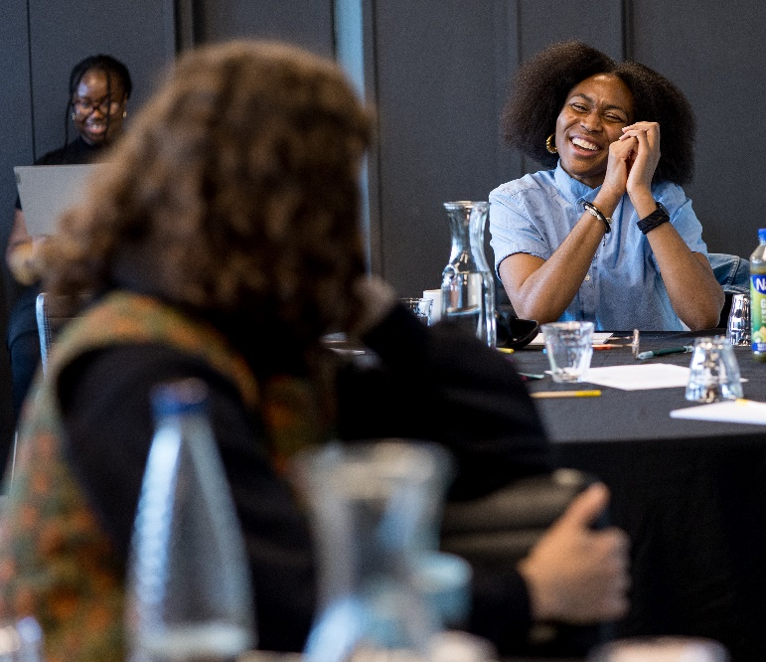
Funded by Standard Chartered Foundation

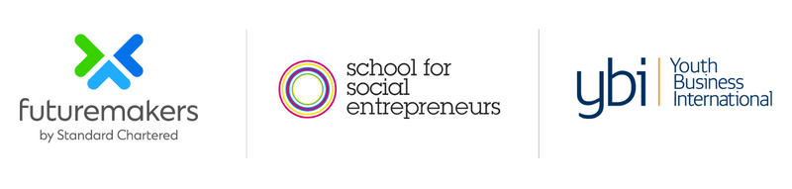

Overview

Applications are now open for younger female-identifying and non-binary people in London and Liverpool to join a group of fellow entrepreneurs for an exciting nine month learning experience. Together they will develop new business skills to grow their social impact businesses and build relationships that can last a lifetime.
Designed by women for women, the course develops personal strengths and abilities to overcome challenges experienced by female-identifying and non-binary people:
- Leading with confidence in the face of gender inequalities
- Managing the mental load of leadership, family and caring responsibilities
- Navigating imposter syndrome and the complexities of self esteem
- Harnessing hormonal cycles to thrive in your business and life
- Maintaining your individuality within business culture
This cohort programme provides a safe space for women from all backgrounds to develop a lasting and supportive network. In this caring group participants will develop the skills, strengths and networks to grow purpose-led enterprises, and in turn create new jobs for underserved communities.
Participants will take part in a free eight-day learning programme, receive bespoke one-to-one business development and modelling support, a sisterly peer network and the chance to pitch for one of four Match Trading grants of up to £7,000.
We recognise the intersectional barriers faced by many in the UK and encourage applications from women in marginalised or underrepresented groups.
“This programme is fantastic, it’s a great opportunity to bring women together to hear their stories and to network. We can learn from each other about what we did right, what we did wrong – and also have experts that can build our skills.”
Katherine Tinoco, Art PerUK

Key details:

- This programme is open to women, including trans women, female-identifying and non-binary people

- The Women’s Enterprise Growth Programme is aimed at leaders of organisations aged 18-35, living or working in London or Liverpool (ie the City of London and the 32 boroughs of London or the Liverpool City Region). Their enterprises should have been running for less than five years, with an income of between £10,000 and £100,000

- The programme is designed for people wanting to build their personal resilience and business sustainability, to increase customer acquisition, and grow their income

The Women’s Enterprise Growth Programme is run by The School for Social Entrepreneurs with support from Youth Business International (YBI) and funded by Standard Chartered Foundation as part of Futuremakers by Standard Chartered.

How you can help
We’re looking for organisations and individuals who can help us spread the word about The Women’s Enterprise Growth Programme. We want to reach as many organisations as possible to share this opportunity. If you have an audience that might benefit from the programme please do share the following messages in whatever way works for you. Sample newsletter copy and social posts are below to make this easy.

If you want more information or to get more involved in SSE courses and events, please contact our comms partnerships manager, Rhys on 07970 167 230 or rhys.pritchard@sse.org.uk

Sample posts

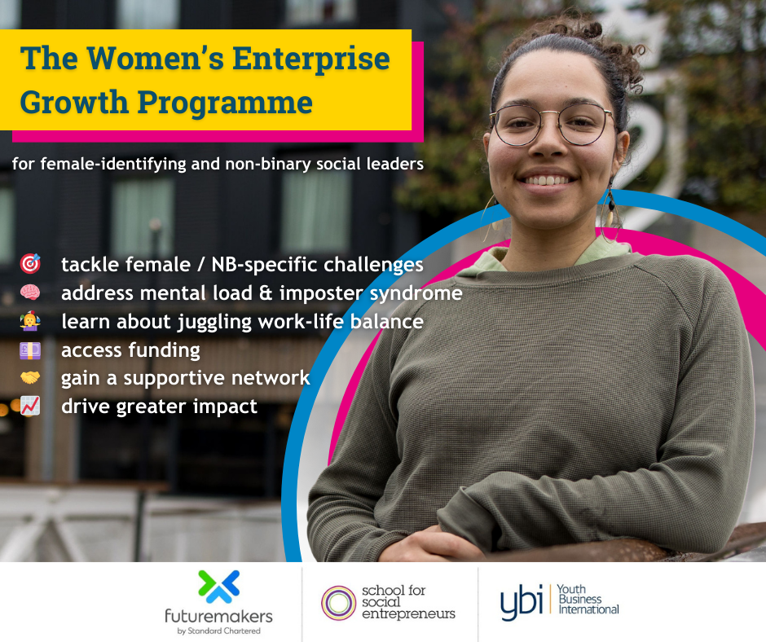

Twitter

Twitter post 1
🚀 Ready to elevate your purpose-led enterprise? Join the Women’s Enterprise Growth Programme! 9 months of FREE training for female-identifying and NB entrepreneurs aged 18-35 in London & Liverpool https://www.the-sse.org/courses/womens-enterprise-growth-programme/
Twitter post 2
🔥 Fuel your enterprise’s growth and make a lasting impact! Join us in London & Liverpool for a 9-month journey with the Women’s Enterprise Growth Programme. For ambitious female-identifying and NB entrepreneurs https://www.the-sse.org/courses/womens-enterprise-growth-programme/
Twitter post 3
🌱 Grow your impact & income with our Women’s Enterprise Growth Programme! 8 days of study, bespoke support, and the chance to pitch for a grant. For female-identifying and NB entrepreneurs in London & Liverpool. https://www.the-sse.org/courses/womens-enterprise-growth-programme/

Facebook
Did you know that your hormonal cycle can significantly impact the way in which you lead your impact-driven venture at any one time? 📣
The School for Social Entrepreneurs, Youth Business International and Standard Chartered Foundation have teamed up for the Women’s Enterprise Growth Programme 2024, by women, for women - including trans women, female-identifying and non-binary people.
If you're aged between 18-35 in London and Liverpool, apply now to address barriers such as managing the mental load at home, navigating imposter syndrome, hormonal cycles and work-life balance ⚖
You’ll also develop the skills, strengths and networks required to grow purpose-led enterprises and in turn create new jobs for underserved communities 📍
Here's what you can expect:
🌿 Bespoke 1:1 business development and modelling support
🧠 8 days of focused study
🌎 Opportunities to build supportive peer networks
🤝 Access to Contract Readiness support
🏆 A graduation event in December 2025 to celebrate your achievements

Apply now: https://www.the-sse.org/courses/womens-enterprise-growth-programme/

Instagram
Did you know that your hormonal cycle can significantly impact the way in which you lead your impact-driven venture at any one time? 📣
@The School for Social Entrepreneurs, @Youth Business International and @Standard Chartered Foundation have teamed up for the Women’s Enterprise Growth Programme 2024, by women, for women - including trans women, female-identifying and non-binary people ✨
If you're aged between 18-35 in London and Liverpool, apply now to address barriers such as managing the mental load at home, navigating imposter syndrome, hormonal cycles and work-life balance ⚖
You’ll also develop the skills, strengths and networks required to grow purpose-led enterprises and in turn create new jobs for underserved communities 📍
Read more and apply via the link in our bio 👆
#SchoolforSocialEntrepreneurs #YouthBusinessInternational #StandardCharteredFoundation #WomensEnterprise #womeninbusiness (etc)

Email / Linkedin copy
Applications are now open for young women - including trans women, female-identifying and non-binary people - in London and Liverpool to join to the Women’s Enterprise Growth Programme.
Designed by women for women, this course delivers tailored support for the unique experiences and barriers you’re facing:
- Leading with confidence in the face of gender inequalities
- Managing the mental load of leadership, family and caring responsibilities
- Navigating imposter syndrome and the complexities of self esteem
- Harnessing hormonal cycles to thrive in your business and life
- Maintaining your individuality within business culture
Participants will take part in a free eight-day learning programme, receive bespoke one-to-one business development and modelling support, a supportive peer network and the chance to pitch for one of four Match Trading grants of up to £7,000.
This exciting programme will support women aged 18-35 living or working in London and Liverpool to develop the skills, strengths and networks required to grow purpose-led enterprises and in turn create new jobs for underserved communities.
The programme is run by the School for Social Entrepreneurs with support from Youth Business International (YBI) and funded by Standard Chartered Foundation as part of Futuremakers by Standard Chartered.
SSE are running information sessions where you can find out more about the programme on
- Tuesday October 15, 12pm
- Wednesday October 30, 5pm
- Thursday November 7, 6pm
Further details can be found at https://www.the-sse.org/courses/womens-enterprise-growth-programme/

